 | Grilled Cheese,  Shaker Heights High School  Week 3  Tomato Soup, Roasted Corn,  Fresh Fruit  Variety of Fluid milk | General Tso Chicken, Seasoned Rice, Roasted Broccoli  Fresh Fruit  A Variety of Fluid Milk | Wing Day  Assorted Sauce’s, Cheesy Potatoes, Carrots & Celery, Pretzel Stick  Fresh Fruit  A Variety of Fluid Milk | Breakfast for Lunch  French Toast, Sausage, Hashbrowns  Fresh Fruit  A Variety of Fluid Milk | Chicken Penne Alfredo, Roasted Green Beans, Garlic Roll Fresh Fruit  A Variety of Fluid Milk
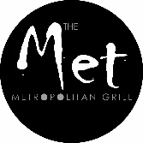 | Southwest Black Bean Burger  Cheeseburger  Spicy Chicken Sandwich | Southwest Black Bean Burger  Cheeseburger  Spicy Chicken Sandwich | Southwest Black Bean Burger  Cheeseburger  Spicy Chicken Sandwich | Southwest Black Bean Burger  Cheeseburger  Spicy Chicken Sandwich | Southwest Black Bean Burger  Cheeseburger  Spicy Chicken Sandwich`
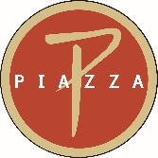 | Hot Italian Pizza  Pepperoni Pizza  Cheese Pizza | Meatball Pizza  Pepperoni Pizza  Cheese Pizza | Supreme Pizza  Pepperoni Pizza  Cheese Pizza | Sausage Pizza  Pepperoni Pizza  Cheese Pizza | Veggie Pizza  Pepperoni Pizza  Cheese Pizza
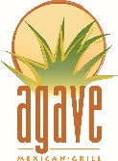 | Daily Choice of: Bowl, Burrito, Nachos  Protein Choices: Taco Beef, Fajita Chicken, Carnitas, Tofu  Assorted Sides and Toppings
Protein Choices: Seasoned Beef, Marinated Chicken, Marinated Tofu
Choice of Rice or WG Noodles,
Assorted Fresh Vegetables, Sauces
Contact your Chef Resident Director, Mark Jacobs, at 216-295-4342
or email Jacobs_m@shaker.org for questions or comments.

This institution is an equal opportunity provider.

